MY SQL GLA2 DAY 2 ASSIGNMENT
1)List the different types of relations in SQL with examples
1. one to one: one to one relationship is a link between the information in two tables, where
Each record in each table appears only once Example: user to password one employee can only have one office.
2. one to many: one to many relationships, one record in a table can be associated with one or more records in another table. Example: Class to Student, customer can have many sales orders
3) Many-to-many: Many-to-many relationships occur when multiple records in one table are related to multiple records in another table. Example : Products and suppliers Doctor to patients
4. Many to one Example: A relationship between one entity to that contains several values and refers to another several instances Example: City to Country
5. Self-raising relationships Example: Self-raising table occurs one table relates to another Column
Example: Staff to manager relation and Manager relates to staff

2)NORMALISATION:
Normalization refers to a process that makes something more normal or regular. Most commonly it refers to Normalization or social Normalization the process through which ideas and behaviours that may fall outside of social norms come to be regarded as “normal”

3)Modify the Query to show the population of the Germany
SELECT population
From world. Country
Where name=’Germany’;

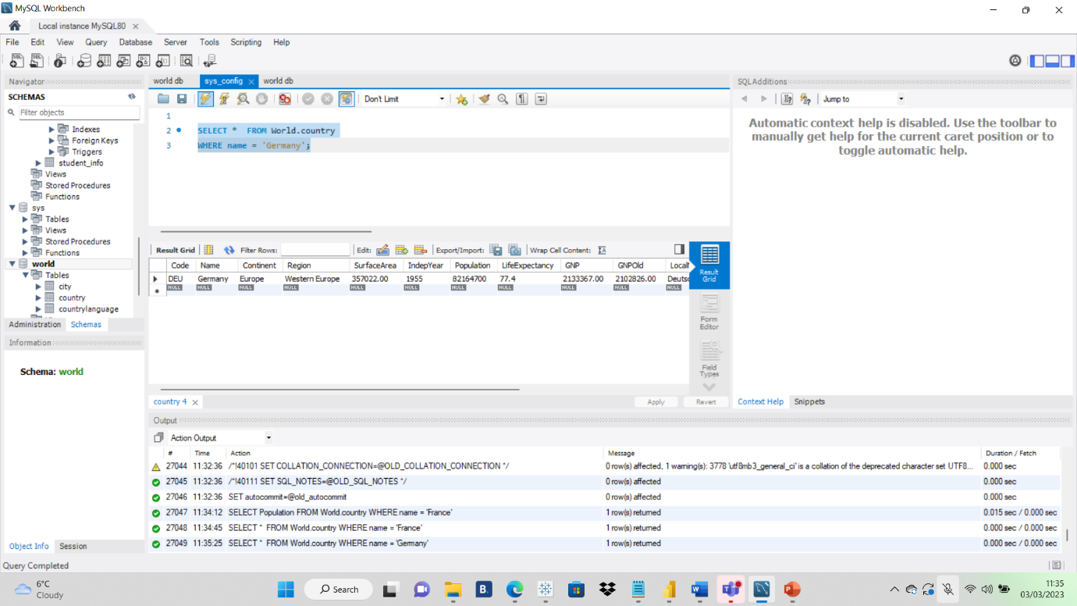
4)SELECT QUERY which gives name of the countries begin with u
SELECT name
FROM world.country
WHERE name like = ’U% ’;
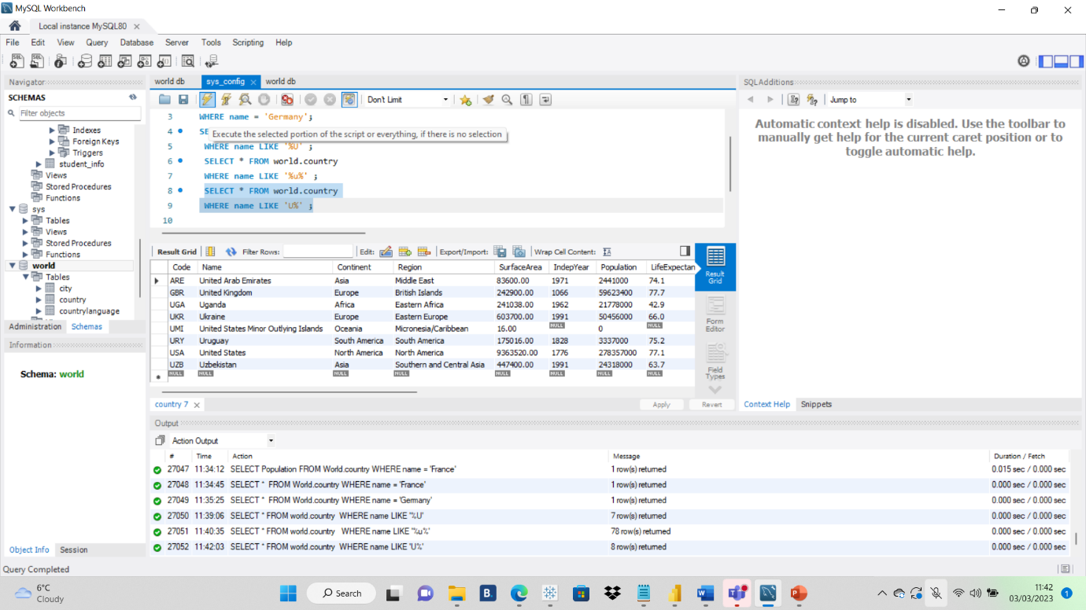
5)Answer which shows the intended result should be the continent of FRANCE
Select a continent From the world The name = ‘France’
ANSWER: ‘France’ should be “France”

6)Select the query countries which show that end with ‘A’ or ’L’
ANSWER: SELECT name FROM world WHERE LIKE ‘%a’ or ‘%l’;

7)SELECT the QUERY which shows the following Table
ANSWER:
SELECT name, population FROM world WHERE Population between 1000000 and 1250000

MY SQL ASSIGNMENT DAY 2 GLA2
#TASK 1

Using count get the number of cities in USA
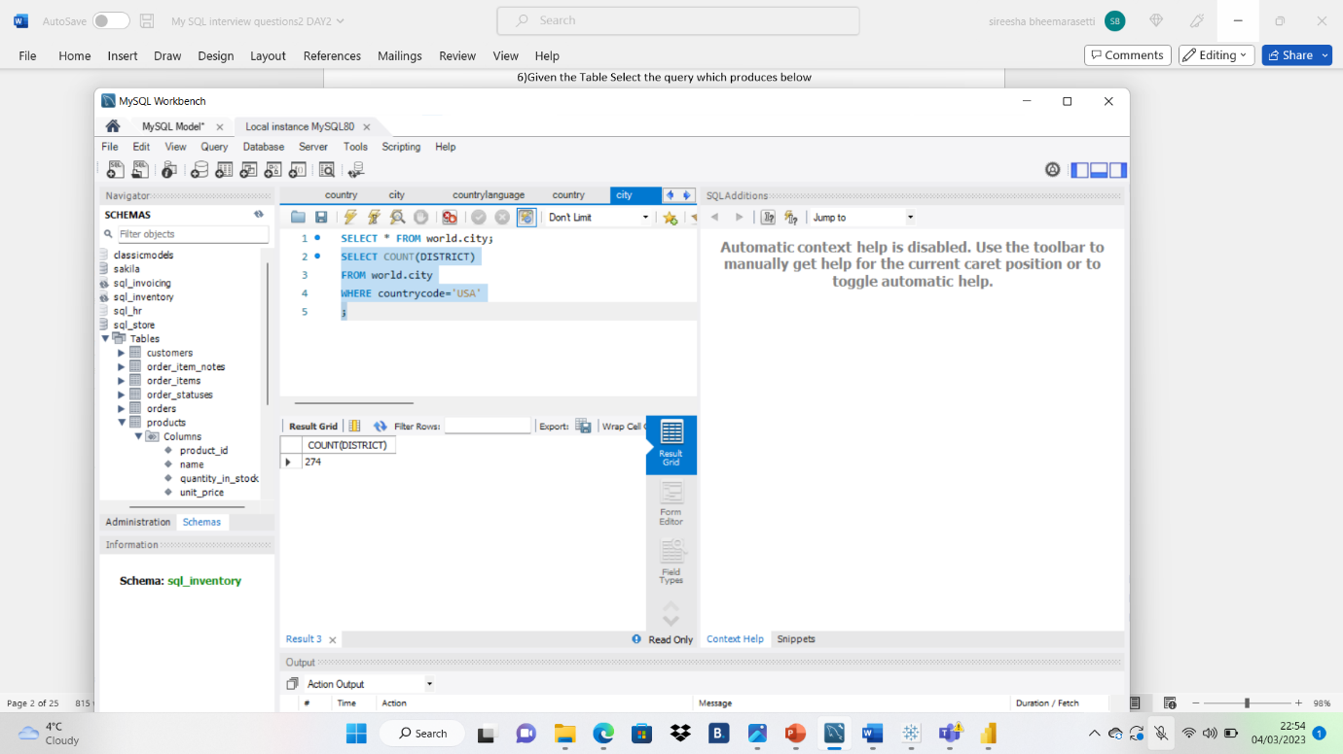
# TASK2
Find out Average population AND LIFE EXPECTANCY in ARGENTINA (’ ARG’)

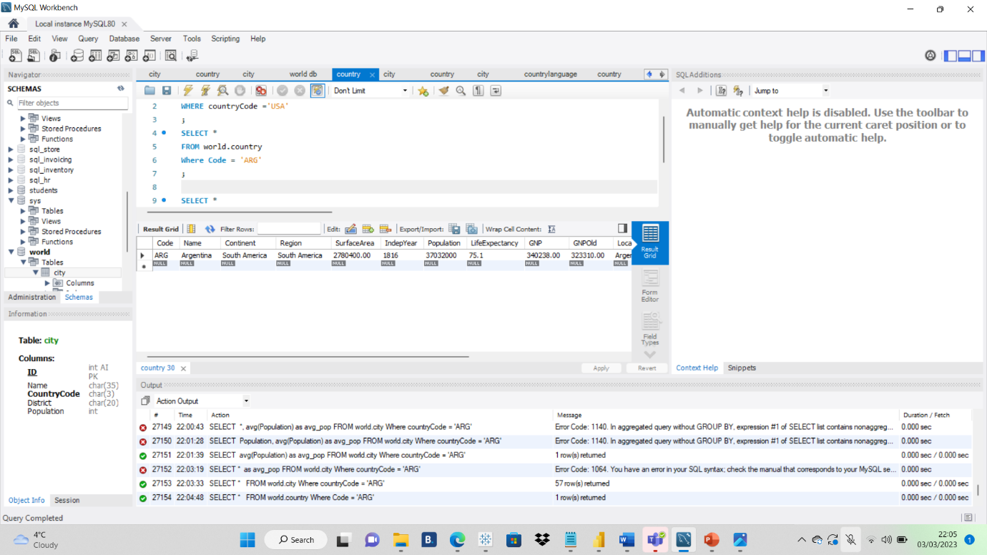
# TASK 3
Using ORDER BY LIMIT WHAT COUNTRY HAS HIGHEST life expectancy

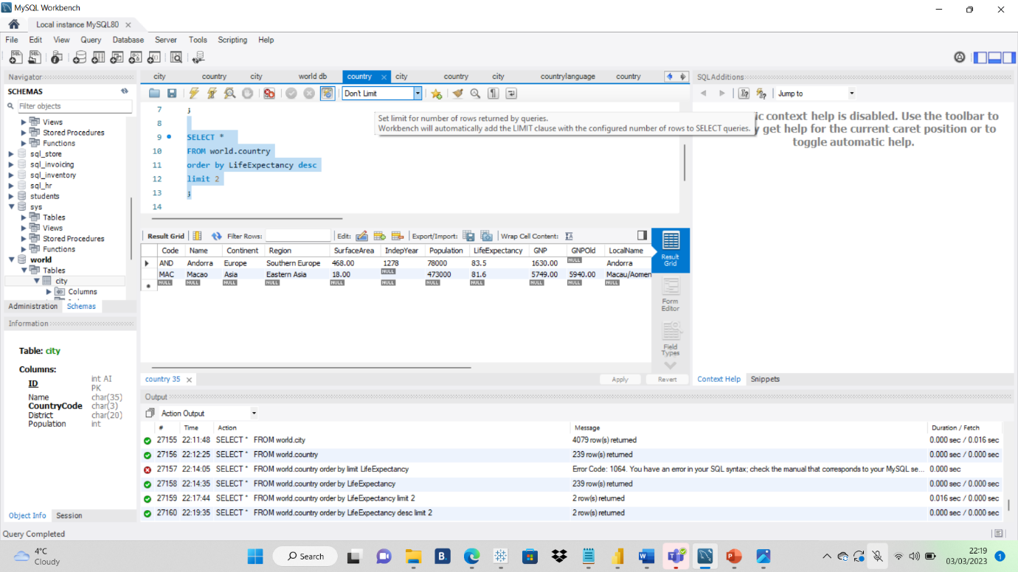

# TASK 4
SELECT the 25 countries around the world starts with LETTER ‘ F ‘with a single QUERY
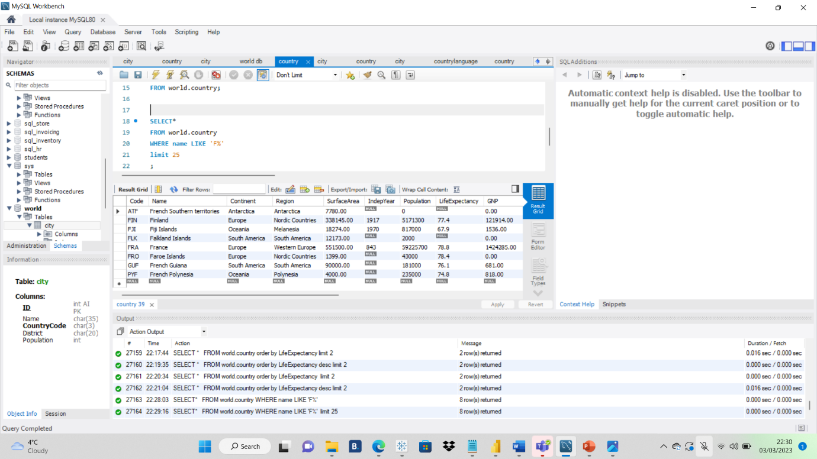

#TASK 5
CREATE SQL STATEMENT DISPLAY COLUMN ID, NAME ,POPULATION USING FROM THE CITY TABLE LIMIT BY 10

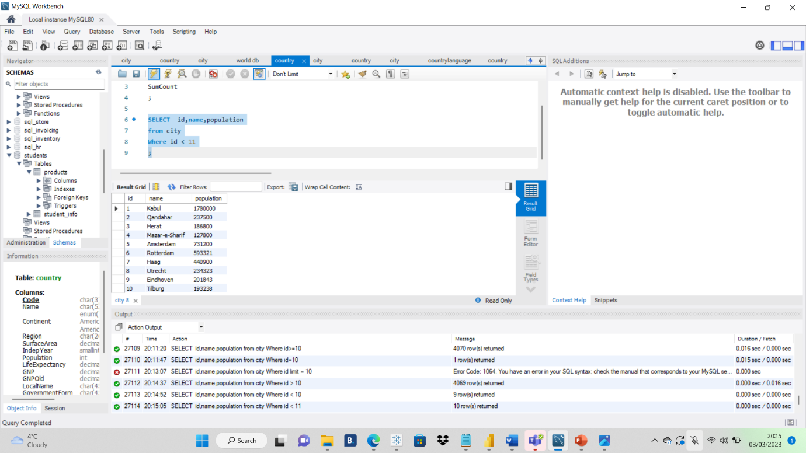

#TASK 6
CREATE SQL STATEMENT TO FIND THOSE CITIES FROM THE CITY TABLE WHOSE POPULATION IS LARGER THAN 20000000
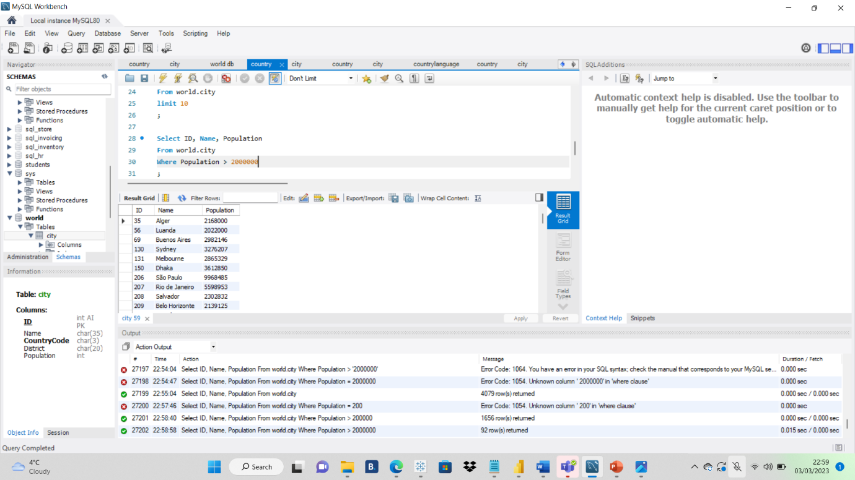
#TASK7
CREATE SQL FROM CITY TABLE WHOSE CITY NAMES BEGIN WITH ‘BE’ PREFIX
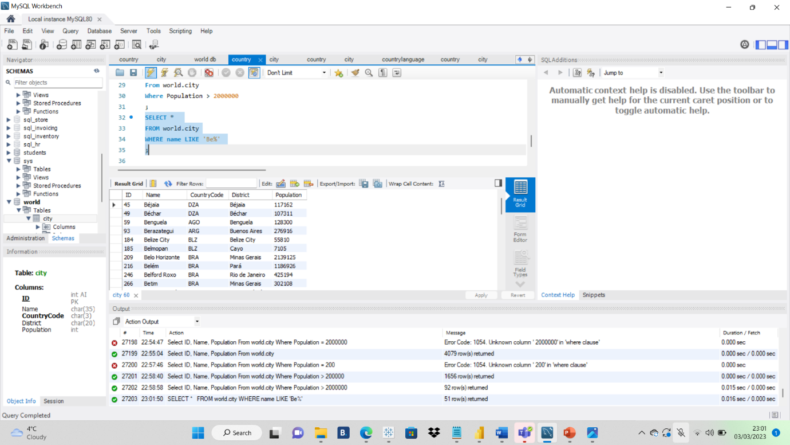
#TASK 8
CREATE SQL STATEMENT TO FIND CITIES FROM THE CITY TABLE WHOSE POPULATION FROM CITY TABLE BETWEEN 500000 TO 1000000

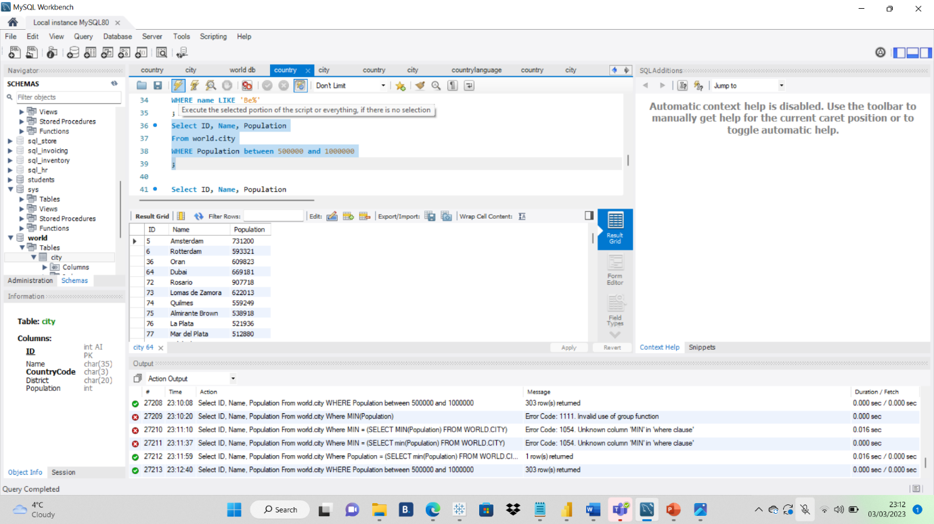

#TASK 9

CREATE SQL STATEMENT WHICH CITY LOWEST POPULATION CITY USING CITY TABLE

EER DIAGRAM
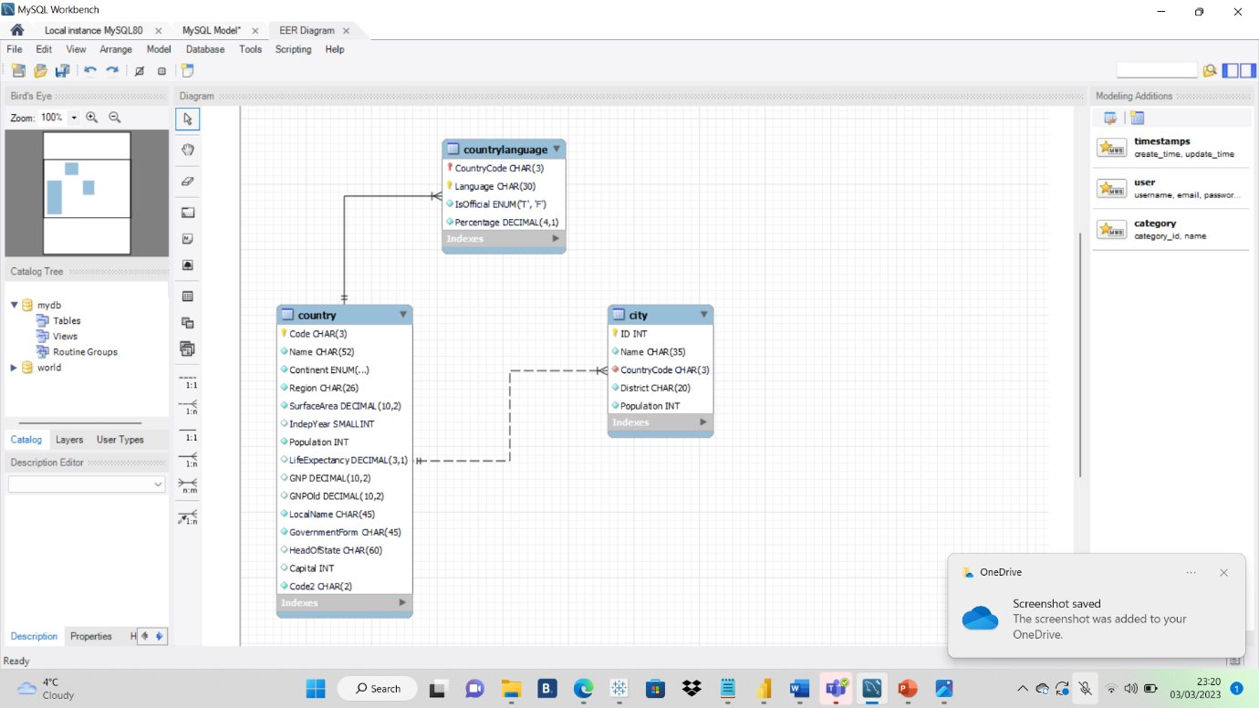

PRIMARY KEY IN CITY TABLE =ID
PRIMARY KEY IN COUNTRY TABLE=COUNTRY CODE
PRIMARY KEY IN COUNTRY LANGUAGE TABLE=COUNTRY CODE
FOREIGN KEY IN CITY TABLE =CONTRYCODE
FOREIGN KEY IN COUNTRY LANGUAGE TABLE =COUNTRY CODE

